**Central Asia Regional Network Meeting: key achievements of 2020 and plans for 2021**

|  |
| --- |
| **C:\Users\Nailya\Desktop\UNDP_GSP_2020-2021\REGIONAL NETWORK MEETING ONLINE\Outputs\group photo 1.jpg** |

# Summary Report

## Time: 14:00 – 16:30 Tashkent time | Date: December 3rd, 2020 | Format: [Online](https://www.un-gsp.org/event/central-asia-regional-network-meeting-key-achievements-2020-and-plans-2021)

All presentations are located at the GSP webpage: <http://www.un-gsp.org/event/central-asia-regional-network-meeting-key-achievements-2020-and-plans-2021>

# Background:

Since 2019 UNDP/UNEP Global Support Programme has been activating its work on technical support for the region of Central Asia and the Caucasus. With the **first regional network meeting** to discuss the agenda and progress the countries made on MRV and GHG Inventories ([12-13 November 2019, Almaty, Kazakhstan](http://www.un-gsp.org/event/regional-workshop-measurement-reporting-and-verification-mrv-and-enhanced-transparency)), the **Central Asia Network on MRV and Transparency** was established in 2020 to maintain a dialogue on climate change reporting requirements under the UNFCCC and to proceed to the Enhanced Transparency Frameworks (ETF) by 2024.

Given the interest of the countries of Central Asia and the Caucasus to maintain a peer-to-peer communication annually through a joint in-room event, the second regional network meeting was held on **December 3rd, 2020**. However, given the pandemic situation, this year meeting was organized virtually with the use of the zoom platform.

**Objective:**

The main objective of the second regional network meeting was to **update both members and key stakeholders** *on the progress made by the countries of Central Asia in succeeding towards establishing their domestic MRV* within the assistance received from the GSP Programme, as well as to discuss the next round of country-based and regional activities (MRV, Transparency, GHG Inventories, etc.) in 2021.

**Outputs of the meeting:**

The meeting was attended by 42 participants with 26 of them being women (Annex 2: A list of participants). Participants were represented by Coordinators of National Communications and Biennial Update Reports, senior experts from the national agencies dealing with climate policy who oversee the establishment of MRV and the national enhanced transparency frameworks and experts dealing with data collection and greenhouse gas inventory. All national participants were from the region of Central Asia and the Caucasus (Armenia and Azerbaijan) and Belarus. The meeting was also attended by representatives from international agencies who are dealing with climate change and transparency in the region, including UNFCCC, UNDP, and ICAT.

Selected countries of the network presented their intermediate findings on establishing MRV systems at the national level and shared the results on gender mainstreaming progress. Details are below:

1. **Nailya Mustaeva**, Central Asia Network Coordinator on MRV and transparency

The first presentation was dedicated to the reporting on the progress of the Central Asia Network on MRV and Transparency over the past year: main achievements and results in 2020. In total, **4** national assignments were carried out with the involvement of **5** individual technical consultants, **3** regional webinars were organized, **3** regional trainings of the UNFCCC secretariat were supported, and **1** national consultation was held. In total, **130 participants** took 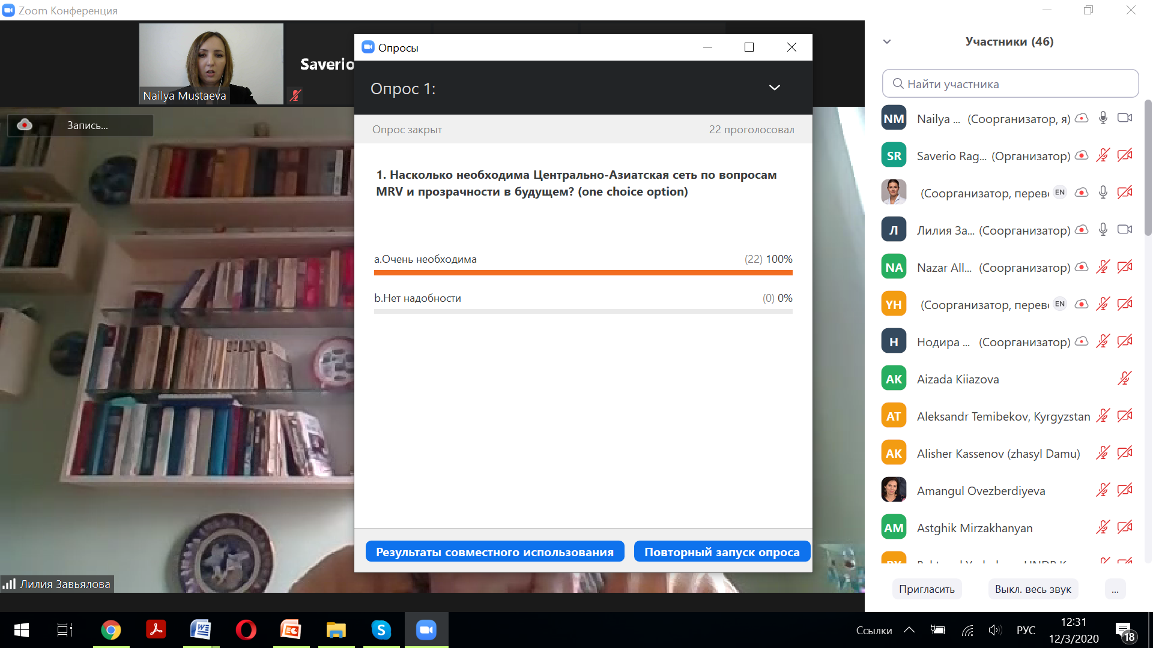part in the events, out of which: 10-30 experts were regular participants. The ratio of women representation was 60% against 40% (men).

The main areas of work identified by the network members are the following:

* Capacity building of the state and non-state agencies and institutions

Fig 1. Role of the Central Asia Network on MRV and transparency

* Technical support at the national level (national assessments and recommendations)
* Involvement of the statistic agencies and departments, who are dealing with data collection and analysis on GHG/mitigation
* Regular information and experience exchange among the members (by conducting annual network meetings)

Based on the results of the poll, the role of the network became an important platform for exchange of materials and information, which mainly addresses the topics of MRV, transparency, ETF and GHG Inventories. As stated by the participants the work of the network should continue in the future (Fig. 1.).

1. **Liliya Zavyalova**, National Expert on MRV and mitigation in Uzbekistan

The main focus of the presentation was on the intermediate results of the technical and institutional capacity assessment on establishing the MRV system in Uzbekistan. In her presentation, Ms Zavyalova addressed both gaps and opportunities of each element of the system, with a particular focus on (a) institutional arrangements, (b) institutional structure and set-up, and (c) legal and regulatory frameworks for climate change actions in Uzbekistan. The main proposals touched upon the availability (continuation of work) of the Interdepartmental Council on Climate Change under the leadership of the Cabinet of Ministers of the Republic of Uzbekistan. At the same time, Uzhydromet has to continue its role in being the operational body with a permanent office on climate change. Also, at the national level it is important to have regulations, considering:

* Mandate, composition and functions of the institutional set-up for climate change
* Mechanisms of interaction and communication of respected agencies on climate change issues
* Mechanisms of interaction and communication on mitigation and adaptation issues, technical/financial support (financing, technology transfer and capacity building)

One of the most important proposals is to adopt a separate regulatory document on climate change in Uzbekistan to assure regular process on transparency, MRV and reporting.

With reference to the results of the poll, which asked the participants to answer what type of difficulties they face in establishing the domestic MRV systems, the majority of respondents consider that the *lack of capacity of government agencies* dealing with climate policy is the biggest challenge. At the same time, the *lack of materials* (handbooks, guidance) in Russian and *poorly functioning institutional mechanisms* at the national level also bring difficulties in their work process (Fig. 2).

1. **Nazar Allaberdiyev,** National Expert on MRV and GHG Inventories in Turkmenistan

The main objective was to present the initial results of the assignment performed on the development of a roadmap for the establishment of the national MRV system with a focus on the GHG inventory in Turkmenistan. The main recommendations are:

* Set-up a permanent structure for carrying out regular GHG inventories and other work on climate change in Turkmenistan;
* 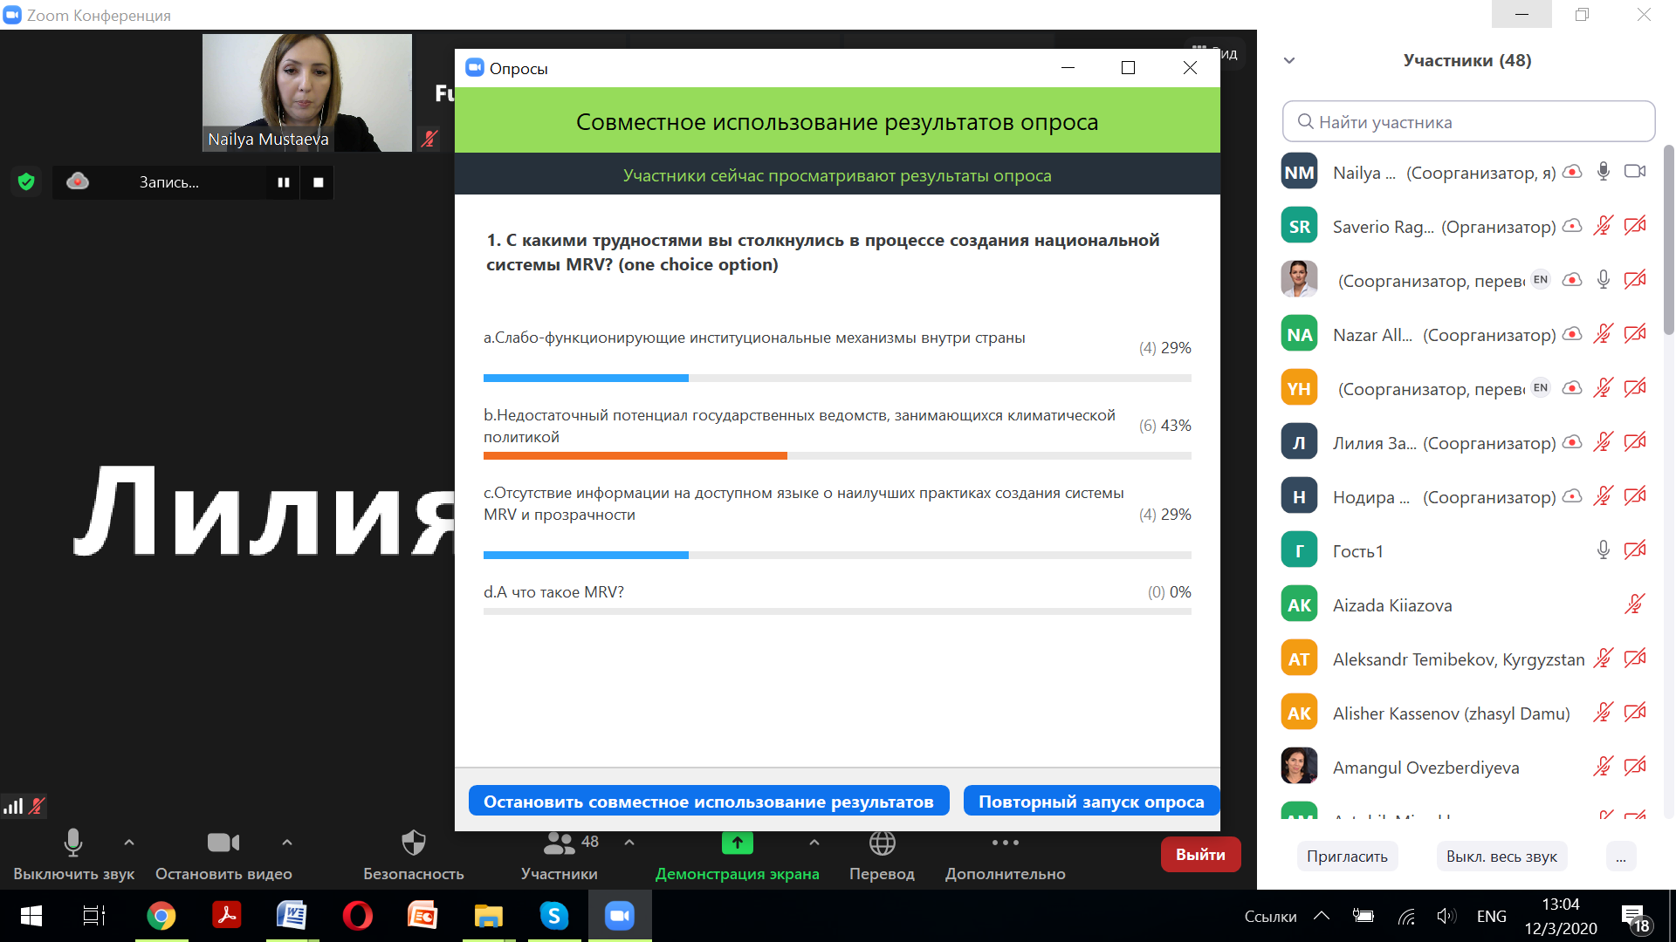Develop and implement the data collection system with binding agreements between the data providers and the responsible entity that processes and compiles the data;
* Establish the quality assurance and quality control (QA/QC) system and technical support processes to ensure regular reporting;
* Develop and implement the capacity building programme for training the respective experts on various aspects of climate change in Turkmenistan;

Fig 2. Difficulties and challenges towards establishing domestic MRV systems

* Set-up the regular information system to support the collection and processing of GHG inventory data and align it with other areas of MRV.

At the same time, a number of technical recommendations were also presented which, as expected, will be tested and used within the preparation of the Fourth National Communication:

* Include analysis of key categories (by level and trends): this will help more accurately plan next rounds of the national GHG inventory (Chapter 4, 2006 IPCC).
* Include the analysis of the GHG inventory uncertainties: this will also assist in striving towards the improved quality of the national GHG Inventories (Chapter 3, IPCC 2006).
* Include a description of the methods for calculating the emissions for at least key categories.
* Make efforts to improve statistics on activity data in Agriculture, Waste and LULUCF sectors.
* Include information and data for the category “Manure storage and use” in the Agriculture sector.
* Include at least the information on “Air conditioning and refrigeration” category in the Industrial Processes sector.
* Include at least the information on “Wastewater treatment and discharge” category in the Waste Sector.
* Include the information on discussion of the emission distribution by gas in each sector.

1. **Nodira Rakhmonberdieva**, National Expert on gender and climate change in Tajikistan

The final speech of the meeting was the presentation of the interim results of the initial gender analysis on climate change in Tajikistan. In particular, the findings touched upon the difficulties and gaps in mainstreaming gender into the MRV system in the country, which, in fact, may be acceptable for other countries of Central Asia:

* Legislative and legal framework: lack of interrelated actions and clear operational procedures to mainstream gender into the current action plans and programmes on climate change within the respected agencies;
* Weak coordination on interrelated actions between relevant departments dealing with gender and climate change;
* Lack of a single institutional structure that would align/integrate gender and climate change;
* Absence of the National Focal Point on Gender and Climate Change who should have been appointed in accordance with recent decisions of the Conference of the Parties (COP-25);
* The representation of women in the national delegation for the Conference of the Parties is low;
* Lack of targeted research or assessments related to gender and climate change on a regular basis and incorporation of results into climate reporting (NCs and BURs);
* The level of awareness and technical capacity among governmental officials about the interrelated actions of gender and climate change needs to be improved;
* Low percentage (%) of girls among students in specialized educational institutions and universities in 2018/19 in the context of specialties related to the environment and climate change issues;

At the same time, main recommendations for improving reporting of interrelated actions of gender and climate change are:

* Appoint the National Focal Point on Gender and Climate Change (UNFCCC)
* Develop methodological manuals for conducting interrelated research and studies ("gender + climate")
* Develop the M&E matrix with the introduction of gender-sensitive indicators for climate policy (Adaptation Action Plans, NC, BURs, NDC)
* Build capacities of civil servants (Committee for Women and Family Affairs, Committee for Emergency Situations, Environmental Agencies, etc.) on the topic "gender + climate"
* Perform trainings of professional personnel (ToT, possibly on the basis of specialized institutes)
* Improve access to finance for civil society organizations working on climate change and rural initiatives for women
* Expand community awareness of the risks and threats of natural disasters associated with climate change.

According to the results of the poll, the topic of gender issues is important, however, there were not so many specialists among the participants, who deal with this topic directly. In the future, one need to take into account the participation of gender specialists and should include them into the list of participants when planning activities on climate change and MRV issues (Fig 3.).

1. **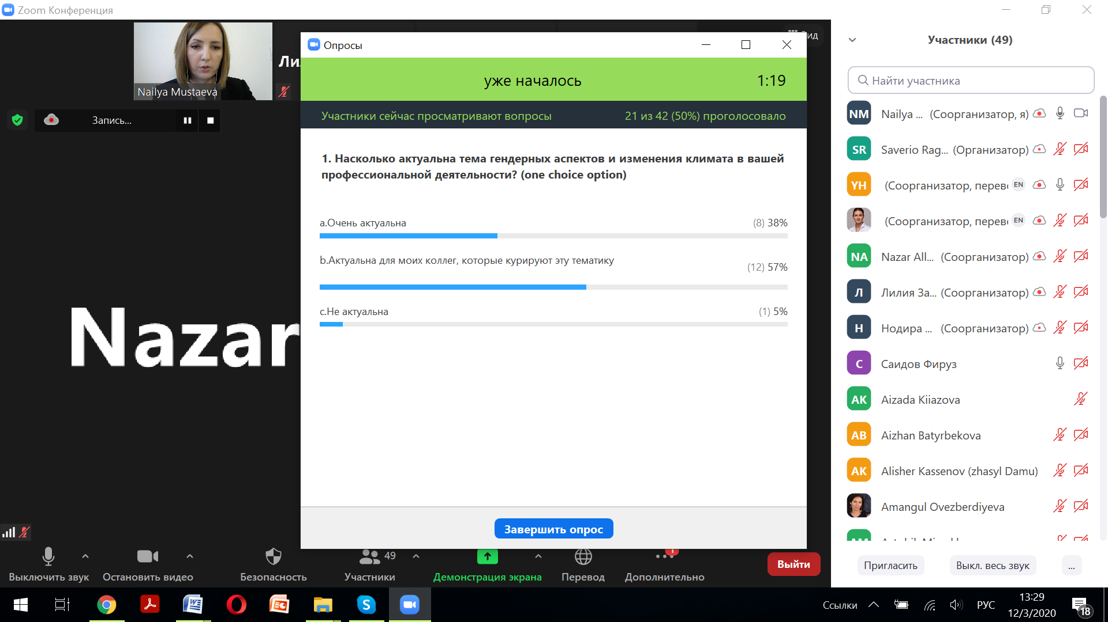Dr. Henning Wuester**, Director, Initiative for Climate Action Transparency (ICAT)

The ICAT Director made a very short presentation about ICAT and informed the participants about the objectives of the program, which, likewise the current GSP programme, aims to strengthening capacity on MRV and transparency. It is expected that in 2021, there will be an opportunity for the Central Asian countries to join the initiative and receive technical assistance in implementation of various activities and projects dedicated to transparency of climate actions, namely, those related to emission reduction and mitigation, GHG inventories, strengthening institutional arrangements and adaptation/resilience.

Fig 3. Importance of the gender and climate change topic in Central Asia

The final part of the event was devoted to discussion that aimed to determine priority areas of interventions and potential activities that the Central Asian countries plan to implement in 2021, and which require financial and technical support.

According to the results of the poll, such activities are correlated with the following areas (top-down priority - Figure 4):

1. Capacity building by delivering trainings, seminars and online conferences
2. Preparation of publications and learning materials in Russian
3. Conducting bilateral or regional consultations with colleagues in the region
4. Conducting research and assessments to reduce GHG emissions
5. Assistance in carrying-out and calculating the GHG inventories

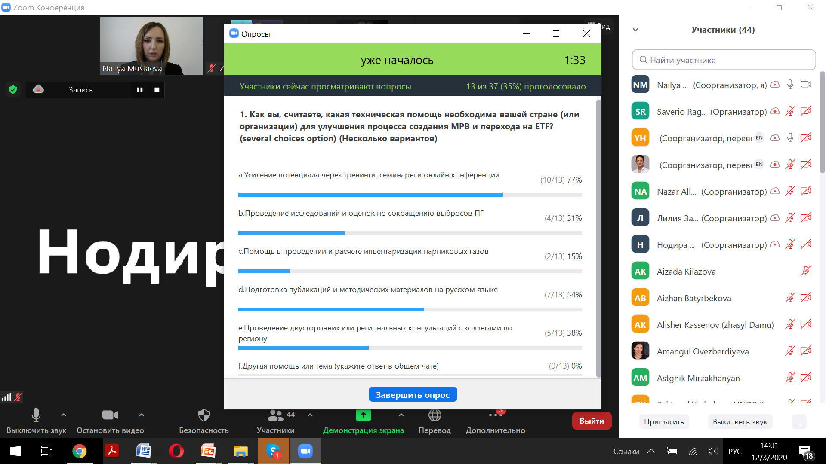In addition to the areas outlined above, participants also highlighted the importance of supporting the establishment of the **MRV for mitigation** (emission reduction) **and adaptation**, as well as further exploring the **interrelated actions of gender and climate change** for reporting. Also, improving the *greenhouse gas inventory system* and compiling regular national inventories, along with *improving the data collection process* and the *involvement of statisticians*, are important aspects of the required assistance in the Central Asian region. Moreover, the use of informal modes of communication has been proposed as additional means of information exchange.

At the end of the regional meeting, the participants shared personal contacts and thanked everyone for attending and hosting the event.

Fig 4. Priorities for interventions on MRV in 2021 for Central Asia

**Annex 1.**

**Agenda**

|  |  |  |
| --- | --- | --- |
| **Time** | **Session/Module** | **Speaker/Facilitator** |
| 14:00 – 14:10 | **Opening session and welcoming remarks**  **Moderator:** Ms. Nailya Mustaeva, Central Asian Network Coordinator | Mr. Damiano Borgogno, GSP Coordinator |
| 14:10 – 14:15 | **Group Photo** | Mr. Saverio Ragazzi, GSP Specialist |
| 14:15 - 14:30 | **Progress of the Central Asia Network in 2020** | Ms. Nailya Mustaeva, Central Asian Network Coordinator |
| 14:30 - 14:40 | *Interaction and Q&A session* | Ms. Nailya Mustaeva, Central Asian Network Coordinator |
| 14:40 - 14:55 | **Initial technical and institutional assessment on MRV in Uzbekistan:** gaps and perspectives | Ms. Liliya Zavyalova, National Expert on MRV and Mitigation, Uzbekistan |
| 14:55 - 15:05 | *Interaction and Q&A session* | Ms. Nailya Mustaeva, Central Asian Network Coordinator |
| 15:05 - 15:20 | **Establishing domestic MRV in Turkmenistan:** developing a comprehensive road map towards systematic GHG Inventories | Mr. Nazar Allaberdiyev, National Expert on MRV and GHG, Turkmenistan |
| 15:20 - 15:30 | *Interaction and Q&A session* | Ms. Nailya Mustaeva, Central Asian Network Coordinator |
| 15:30 - 15:45 | **Mainstreaming gender in MRV:** developing the initial gender analysis in Tajikistan | Ms. Nodira Rakhmonberdieva, National Expert on Gender, Tajikistan |
| 15:45 - 15:55 | *Interaction and Q&A session* | Ms. Nailya Mustaeva, Central Asian Network Coordinator |
| 15:55 - 16:05 | ICAT Initiative on transparency: opportunities for Central Asia | Dr. Henning Wuester, ICAT Director |
| 16:05 - 16:25 | **Discussion: Plans for 2021**  The countries will exchange on potential activities both country-based and regional ones (MRV, Transparency, GHG Inventories, gender, etc.) which should be considered for the GSP support in 2021 | Ms. Nailya Mustaeva, Central Asian Network Coordinator  Mr. Damiano Borgogno, GSP Coordinator |
| 16:25 - 16:30 | **Wrap-up and closing remarks** | Mr. Damiano Borgogno, GSP Coordinator |

**Annex 2.**

**List of participants**

|  |  |  |  |
| --- | --- | --- | --- |
| Name | Country | Organization | Contacts |
| Zufar Tokpaev | Kazakhstan | Deputy Director of the GHG Inventory Department, JSC Zhasyl Damu | zufartokpaev@mail.ru |
| Elmira Ermakhanova | Kazakhstan | Senior Specialist of the GHG Inventory Department, JSC Zhasyl Damu | [yermakhanova@mail.ru](mailto:yermakhanova@mail.ru) |
| Elmira Satenova | Kazakhstan | Specialist of the GHG Inventory Department, JSC Zhasyl Damu | [e.satenova@mail.ru](mailto:e.satenova@mail.ru) |
| Alisher Kasenov | Kazakhstan | Senior Specialist of the GHG Inventory Department, JSC Zhasyl Damu | [alisherkssenov@gmail.com](mailto:alisherkssenov@gmail.com) |
| Aizhan Shorman | Kazakhstan | Specialist of the GHG Inventory Department, JSC Zhasyl Damu | [shormanaizhan@gmail.com](mailto:shormanaizhan@gmail.ru) |
| Mavzhuda Rozabakieva | Kazakhstan | Specialist of the GHG Inventory Department, JSC Zhasyl Damu | majuda@mail.ru |
| Kanat Abdrahmanov | Kyrgyzstan | Climate Finance Centre | [kanat.abdrahmanov@gmail.com](mailto:kanat.abdrahmanov@gmail.com) |
| Asel Madybaeva | Kyrgyzstan | Climate Finance Centre | aselmadybaeva@gmail.com |
| Lira Zholdubaeva | Kyrgyzstan | CCA/Project Coordinator | lira.zholdubaeva@undp.org |
| Alexander Temirbekov | Kyrgyzstan | UNEP 4NC/BUR Project Consultant | [atemirbekov@mail.ru](mailto:atemirbekov@mail.ru) |
| Vladimir Grebnev | Kyrgyzstan | Climate Change Adaptation Consultant | vladimir.grebnev@gmail.com |
| Baktygul Ysabekova | Kazakhstan | NDC Project Manager, UNDP Kyrgyzstan | baktygul.ysabekova@undp.org |
| Nasriddin Minikulov | Tajikistan | 4NC/BUR Project Coordinator | mnasredin@mail.ru |
| Nodira Rakhmonbedyeva | Tajikistan | Gender and Social Expert, CSO | nodiradj@gmail.com |
| Firuz Saidov | Tajikistan | MRV National Expert | fsaidov@mail.ru |
| Gurbangeldi Allaberdiyev | Turkmenistan | UNFCCC National Focal Point | gallaberdiyev@yandex.ru |
| Amangul Ovezberdyyeva | Turkmenistan | Climate Change Adaptation Project Manager | amangul.ovezberdyyeva@undp.org |
| Nazar Allaverdiyev | Turkmenistan | GHG Inventory Expert | [NAllaberdiyev@inbox.ru](mailto:NAllaberdiyev@inbox.ru) |
| Gozel Atamuradova | Turkmenistan | Ministry of agriculture and environmental protection. Land management specialist | Gozel.atamuradova@mail.ru |
| Amangul Ovezberdyyeva | Turkmenistan | Climate Change Adaptation Project Manager | amangul.ovezberdyyeva@undp.org |
| Raisa Taryannikova | Uzbekistan | 4NC/1BUR National Coordinator | raisa.taryanikova@ncsa.uzsci.net |
| Yuliya Kovalevskaya | Uzbekistan | GHG Inventory Team Leader |  |
| Lyudmila Shardakova | Uzbekistan | NIGMI Uzhydromet | lyudmila.shardakova@gmail.com |
| Olga Belorussova | Uzbekistan | Head of Laboratory, Uzhydromet | olga.belorussova@gmail.com |
| Liliya Zavyalova | Uzbekistan | MRV Expert | zavlilya@gmail.com |
| Sayora Abdullaeva | Uzbekistan | Information Manager, Uzhydromet | sayyora76@mail.ru |
| Marina Sargsyan | Armenia | National Coordinator, NC and BUR project | marina.sargsyan@undp.org |
| Astghik Mirzakhanyan | Armenia | UNDP Climate Change Program | astghik.mirzakhanyan@yahoo.com |
| Dr Fuad Humbatov | Azerbaijan | IPCC National Focal Point. Head of the Mitigation Working Group | fuad.humbatov@mail.ru |
| Sergey Nikitin | Belarus | Project Manager | nikitsin@hotmail.com |
| Vladimir Rak | Belarus | National Mitigation Expert | uladzimir.rak@gmail.com |
| Irina Bubenko | Kazakhstan | Knowledge Management Specialist, CAREC | ibubenko@carececo.org |
| Alexei Sankovski | Belarus | International Expert (GHG and Mitigation) | asankovski@gmail.com |
| Nataliya Vasylyeva | Ukraine | Regional Coordinator on NDC, UNDP Istanbul | nataliya.vasylyeva@undp.org |
| Yevgen Groza | Ukraine | Regional Coordinator for EU4Climate, UNDP Istanbul | yevgen.groza@undp.org |
| Jigme | Bonn | UNFCCC Secretariat | jigme@unfccc.int |
| Violetta Hristova | Bulgaria | International Consultant on MRV, UNDP Kyrgyzstan | hristova@energoconsult.net |
| Dr. Henning Wuester | Bonn | ICAT Director | icat@unops.org |
| Joseph Mensah | Bonn | ICAT Operations Assistant | josephme@unops.org |
| Randa Ahmed | Bonn | ICAT Research and Administration Senior Assistant | randaa@unops.org |
| Sanja Elezovic | Montenegro | International Consultant on gender and climate change, GSP | sanja.elezovic@yahoo.com |
| Damiano Borgonio | Italy | Head of the UNDP/UNEP GSP Programme | damiano.borgonio@undp.org |
| Saverio Ragazzi | Italy | MRV Specialist, GSP | saverio.ragazzi@undp.org |
| Nailya Mustaeva | Moscow | Coordinator on MRV in Central Asia, GSP | nmustaeva@gmail.com |
| Snezana Marstijepovic | Montenegro | Coordinator on MRV, Eastern Europe, GSP | snezana.marstijepovic@undp.org |
| Yana Husak | Kiev | Interpreter | husak.yana@gmail.com |
| Marina Myntsykovska | Kiev | Interpreter | marina.myntsykovska@gmail.com |